University Of Engineering and Technology, Lahore
Computer Engineering Department

Course Name: Programming Fundamentals | Course Code: CMPE-112L
Assignment Type: Lab Report | Dated:
Semester: 1st | Session: 2026 Spring
Lab/Project/Assignment #: 9 | CLOs to be covered: CLO
Lab Title: Exception Handling | Teacher Name: Hafiz Muhammad Mubashar
Lab Evaluation:

CLO1 | Apply appropriate programming techniques to create executable programs to solve well defined problems
 | Level1 | Level2 | Level3 | Level4 | Level5 | Level6
(5)
Total |  |  |  |  |  | /5
Rubrics for Current Lab Evaluation
Scale | Marks | Level | Rubric
Excellent | 5 | L1 | Submitted all lab tasks, BONUS task, have good understanding.
Very Good | 4 | L2 | Submitted the lab tasks but have good understanding
Good | 3 | L3 | Submitted the lab tasks but have weak understanding.
Basic | 2 | L4 | Submitted the lab tasks but have no understanding.
Barely Acceptable | 1 | L5 | Submitted only one lab task.
Not Acceptable | 0 | L6 | Did not attempt
LAB No 1
Lab Goals/Objectives:
• Understand the concept of exception handling.
• Learn to use try, except, and finally blocks.

Equipment Required:
• Computer/Laptop
• Python 3.x
• IDE (IDLE, VS Code, or PyCharm)

Theory:

Exception handling is used to manage errors that occur during program execution. Python uses try, except, else, and finally blocks to catch and handle exceptions, allowing the program to continue running without crashing.

Lab Work:

Exception Handling:

Task 1:
try:
age = int(input("Enter your age: "))
print(f"Your age is {age}")

except ValueError:
print("Please enter a number, not letters!")

Result:
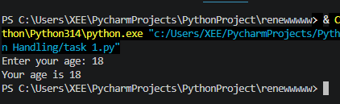

Task 2
try:
a=int(input("enter a number"))
print(a)
except:
print("invalid")
print("helllo world")

Result:
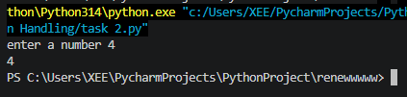

Conclusions:

In this lab, we learned how to handle runtime errors using exception handling in Python. We also understood how try, except, and finally blocks make programs more robust and user-friendly.

